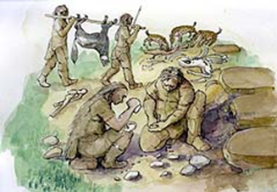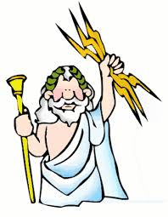

**Clothing**

Please make sure every item of your child’s uniform is named, including coats and shoes. We encourage children to play out in all weather, so please send appropriate clothing, including PE days. Please ensure hats, scarves and gloves are named.

**Drinks**

Please note that children should bring drinks to school in addition to those in their lunch boxes. Milk and water are available throughout the session for the children to access at story time.

**PE**

We advise that children wear their PE kit to school on a Friday. This will ensure children can take part in all PE sessions. Please ensure they have sensible footwear that can also be worn outside and their coat. Children should not wear jewellery and any ear piercings that cannot be taken out should be covered with a plaster.

**Our Home Learning Schedule**

To help your child and share in their learning we would encourage:

* 5 minutes reading together (4 x per week to earn dojo points).
* Name and letter writing.
* Writing lists – can they help make a shopping list or a ‘to do’ list?
* Finding maths problems in everyday situations, comparing quantities, measures or patterns. Can they solve a problem using their number skills?
* Continue to build your child’s home learning evidence on their Dojo portfolio.

**Dates for your diary**

1st October – School Photographs

7th October – Nasal Flu Vaccinations (See Dojo for online link)

22nd October – Break up for Half Term Break

1st November – Start Autumn 2nd Half Term

**Wanderlust**

Empowering our children to learn about the world first hand and make their own informed decisions around sustainable living. Which in turn will enthuse them about being adventurers, explorers and scientists.

**Our topics in Autumn 1**

|  |  |
| --- | --- |
| Autumn | Sticks |
| Nature | Owls |
| Spiders | Pumpkins |

**Our topics in Autumn 2**

|  |  |
| --- | --- |
| Fire | Leaves |
| Hedgehogs | Darkness |

**Books**

The Dot by Peter H Reynolds

We’re Going on a Leaf Hunt by Steve Metzger

Owl Babies by Martin Waddell

Sweep by Louise Greig

Stanley’s Stick by John Hegley

Arghh Spider! by Lydia Monks

Pumpkin Soup by Helen Cooper

The Very Helpful Hedgehog by Rosie Wellesley

Little Glow by Katie Sahota

Can’t You Sleep Little Bear by Martin Wardle

**Math**

**Just Like Me** – Matching and sorting, Comparisons, Patterns

**It’s Me 1,2,3** – Number focus 1, 2 & 3, Shape, Spatial Awareness

**Light and Dark** – Number focus 4 & 5, Shape, Night and Day

**Numberblocks** – Series 1 & 2, Exploring numbers to 10

**Our Curriculum**

|  |  |
| --- | --- |
| Communication and Language | * Listening, Attention and   Understanding   * Speaking |
| Physical development | * Gross Motor Skills * Fine Motor Skills |
| Personal, Social and Emotional Development | * Self-Regulation * Managing Self * Building Relationships |
| Literacy | * Comprehension * Word Reading * Writing |
| Maths | * Number * Numerical Patterns |
| Understanding the World | * Past and Present * People and communities * The Natural World |
| Expressive Arts and Design | * Creating with Materials * Being Imaginative and Expressive |

**Little Wandle Phonics**

|  |  |
| --- | --- |
| Phase 2 graphemes | Tricky Words |
| s, a, t, p |  |
| i, n, m, d |  |
| g, o, c, k | is |
| ck, e, u, r | I |
| h, b, f, l | the |