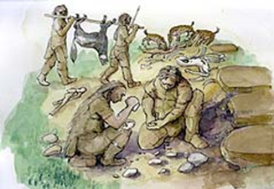[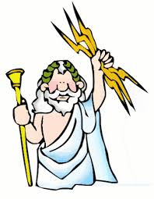](http://www.google.co.uk/url?sa=i&rct=j&q=&esrc=s&frm=1&source=images&cd=&cad=rja&uact=8&ved=0CAcQjRw&url=http://greece.mrdonn.org/greekgods/zeus.html&ei=yFIiVfudFOOt7ga5lIDgDg&bvm=bv.89947451,d.d2s&psig=AFQjCNHt7HQ5bJ9QiiGAY_YP8ZuSPgrk6Q&ust=1428399168094996)

Over the school year we will be looking at ‘Overarching Stories of Humanity’. This half term we will focus on ‘Rags to Riches’.

During this half term, we would like the children to become familiar with the following stories:

• Cinderella

• The Princess and the Frog

• The Ugly Duckling

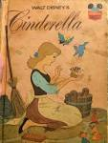 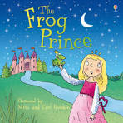 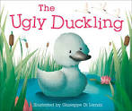

These are stories that we will be reading in Nursery.

Children will be asked to share their ideas about the stories and recall different events.

We will also be thinking about the following question ‘What does it mean to be rich?’ and discussing it with the children.

We will be counting and learning all about numbers from 1 to 10

and comparing collections and beginning to talk about which group has

more/less.

Home Learning

* Share traditional fairy tales.
* Retelling stories.
* Counting groups of object, discussing more and less.
* Write/draw a magic potion
* Make a magic wand.
* Look for numbers in the environment

We are learning the meaning of the following words – **castle, duckling, duck, swan, hatching, lake, feathers, frog, lonely**

**Other Information**

**Dates for your diary**

**Chinese New Year** (Year of the Rat) – 25th January2020

**Meeting for Parents/Carers** – Wordless Books

Thursday 6th February 2020

Am children – 11.15am

Pm children – 2.30am

Please sign up from the end of January.

**School closes** – **Friday 14th February 2020**

**Clothing**

Please make sure every item of your child’s uniform is named, including coats. We encourage children to play out in all weather, so please send appropriate clothing.

We would also appreciate it is you could send spare clothes for your children to wear if needed.

**Drinks**

Please note that children should not bring drinks to school other than in their lunch boxes.

Milk and water are available throughout the session for the children to access whenever they would like.

**\*\***If you have any empty small water bottles/pop bottles with screw lids could you please bring them into Nursery.

We are also saving plastic bottle tops to make collages and use for counting activities.

**\*\***Please remember to add to your child’s profile page on Dojo.

**Our Curriculum**

|  |  |
| --- | --- |
| Communication and Language | * Listening and attention * Understanding * Speaking |
| Physical development | * Moving and handling |
| Personal, social and emotional development | * Self-confidence and self-awareness * Managing feelings and behaviour * Making relationships |
| Literacy | * Reading; Writing |
| Maths | * Numbers * Shapes, space and measures |
| Understanding of the world | * People and communities * The world * Technology |
| Expressive arts and design | * Exploring and using media and materials * Being imaginative |