Curriculum Phase | Term | Week | Key text  Phonics  Maths | Concepts | Artists | Resources Super Six text | Continuous Provision Ideas
Foundation 1  All children in by end of week 2 | Autumn 1 | 2 wks - Settling in  01.09.21 –  10.09.21 | 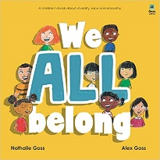  Phase 1 Aspect 1  General sound discrimination- Environmental Sounds.  Tuning into sounds (Wk 2)  Singing a range of number songs.  Sorting – sorting by various attributes | Belonging  Making new friends  Trying new things |  | 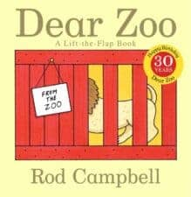  Wk 2 | Self Portraits  Clay faces  Pebble faces  Familiar small world play – TV characters  Dough  Jigsaws  Familiar books  House and people
 |  | 2 wks – Feelings  13.09.21 – 24 .09.21 | 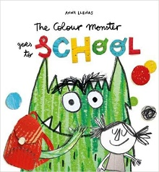  Phase 1 Aspect 1  Environmental Sounds  Listening and remembering sounds  To say number names to 5 in order.  To know that time can be measured using days. | Change |  | 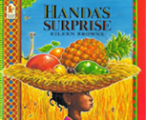  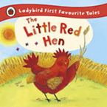 | Tinker table - making faces (beads, necklaces)  Discover  Images – faces  Books  Jigsaws  House and people
 |  | 2 wks – Senses  27.09.21 – 08.10.21 | 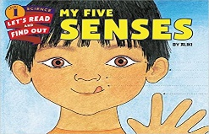  Phase 1 Aspect 1 Environmental Sounds  Talking about sounds  To know that the last number said represents the total number of objects  Singing a range of number songs. | Individuality | 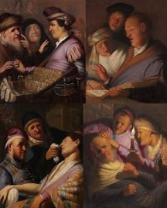  https://tse2.mm.bing.net/th?id=OIP.U7AaT9ShhekwGY1_1is8  TgHaI_&pid=1.7&w=181&h=225&c=8&dpr=1.35 | 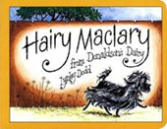 | Tinker table  Discover – how objects feel  Atelier – Sensory objects  Water play  Sand – finding objects  Dough – natural objects  Sensory bottles  Light box  Tasting food
 | Autumn 2  Spring 1 | 2 wks – Light  11.10.21 – 22.10.21 | 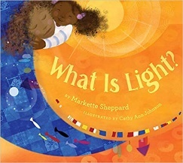  Phase 1 Aspect 2 -General Sound Discrimination - Instrumental Sounds. Tuning into sounds  To show an awareness and name some 2D shapes in the environment.  Singing a range of number songs. | Fear | 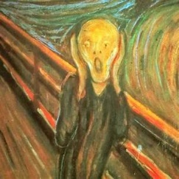  https://tse2.mm.bing.net/  th?id=OIP.5Li-tyhHhCC7BrDlby-R0AHaHa&pid=1.7&w=224&h=  224&c=8&dpr=1.35 | 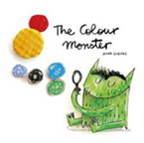  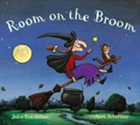 | Torches and dark den  Making dens  Home corner  Light box  Sunshine and shadows  Tracing round shadows  Torches in block play  Colour blocks  Discovery area – coloured cameras  Make a suncatcher
 |  | 2 wks - Colourful  Festivals  1/11/21 –  12/11/21  Diwali – 04/11/21 | 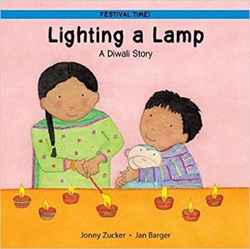  Phase 1 Aspect 2 Instrumental Sounds Talking about sounds  To say number names to 10 in order.  Singing a range of number songs. | Diversity |  | 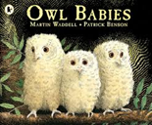  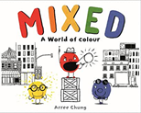 | Divali  Atelier – colours  Role play – dressing up  Make clay pots  Patterns – pegs/light box/printing  Sorting colour – spot tray  Colour mixing – painting/spot tray  Tinker table sorting activities
 |  | 2 wks – Dark  15/11/21 –  26/11/21 | 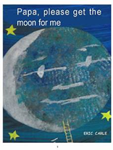  Phase 1 Aspect 2 Instrumental Sounds Listening and remembering sounds  To know that a group of objects can also be represented by a number  Singing a range of number songs. |  | 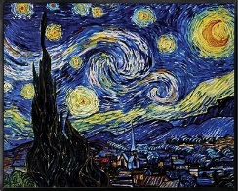  https://th.bing.com/th/id/OIP.3RvTWZ_q99QMgiI_Bn9c  GwHaGA?pid=ImgDet&rs=1 | 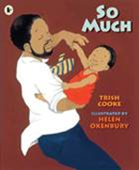  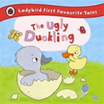 | Watch landing on the moon  Home corner – pyjamas etc  Sequencing cards bedtime routine  Books  Nocturnal small world  Make a hedgehog house  Moon small world  Dark den  Textured paintings  Dough – make the moon  Learn new songs  Silver tins, foil rocks, egg boxes and silver beads – construction area
 |  | 1 wks - Cold  29/11/21 –  3/12/21 | 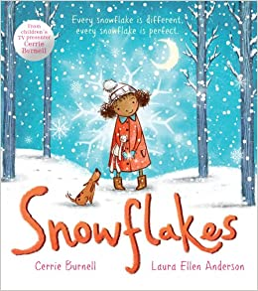  Phase 1 Aspect 4 Rhyme and Rhythm  Tuning into sounds  To know that the last number said represents the total number of objects | Experience | 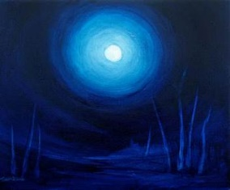  https://fineartamerica.com  /featured/cold-orb-michelle-wiarda.  html | 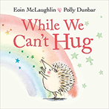 | Winter  Ice habitat – small world  Collage  Making snowflakes – wrapping sticks  Dough imprints  Leaf skeletons on light box  Small world scene  Atelier  Evergreens  Books about winter  Mirrors  Twigs in a vase  Songs  Explorify
 |  | 2 wks – Shiny  06/12/21 –  17/12/21 | 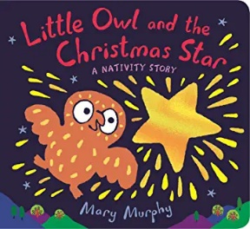  Phase 1 Aspect 3 General Sound Discrimination - Body Percussion  Listening and remembering sounds.  To show an awareness and name some 2D shapes in the environment. | Belief |  | 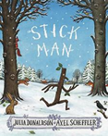 | Christmas  Atelier  Sorting objects  Discovery area – magnets  Making stars  Dough – star cutters
 |  | 3 wks – Wet  03/01/22 – 21/01/22 | 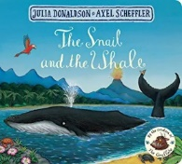  Phase 1 Aspect 4 Rhyme and Rhythm Listening and remembering Sounds  Phase 1 Aspect 6 Voice sounds  Tuning into sounds  To create and repeat simple patterns.  To subitise to 3. |  | 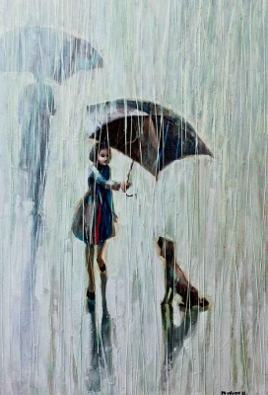  http://ego-alterego.com/2014/03/walking-rain-paintings-igor-mudrov | 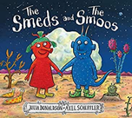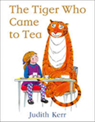  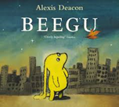 | Floating and sinking  Images related to water  Water feature/tray  Water beads  Small world  Science – discovery area  Rainy day clothing – role play area  Looking for rain clouds  Water in areas around the world  Songs and music – related to rain  Making rain gauges  Waterplay  Petals in ices and magnifying glasses  Explorify
 | Spring 2 | 2 wks – Muddy  24/01/22 –  11/2/22 | 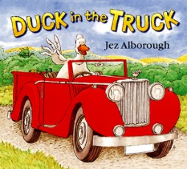  Phase 1 Aspect 5 Alliteration Tuning into sounds  To know number order beyond 5 when counting. (Maths meeting)  To be able to say number names forwards and backwards to 10.  To know that each object should only be counted once. | Happiness |  | 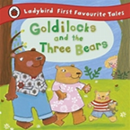  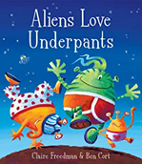 | Dough  Mud kitchen  Farm small world  Soil and spades  Books
 |  | 2 wks -  Ponds  14/02/22 –  25/2/22 | 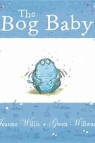  Phase 1 Aspect 5 Alliteration Listening and remembering sounds  To subitise to 3.  To know number order beyond 5 when counting. | Care | 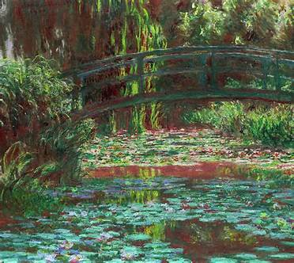  https://tse2.mm.bing.net/th?id=OIP.oIAXcebp6  975Ok6pLSCJOwHaGo&pid=1.7&w=276&h=246&c=  8&dpr=1.35 | 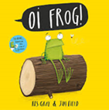 | Books about tadpoles  Small world/water area  Tadpoles – discovery area  Nature journals  Life cycles  Dough – making frogs  5 little speckled frogs  How far can we jump?  Create a small pond  Explorify
 |  | 3 wks – Grow  28/02/22 –  18/03/22 | 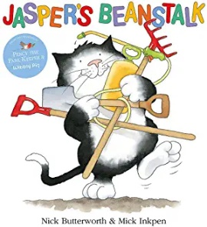  Phase 1 Aspect 5 Alliteration - Talking about sounds  To use the language of more and less to compare amounts.  To know that numbers can be ordered. | Change | 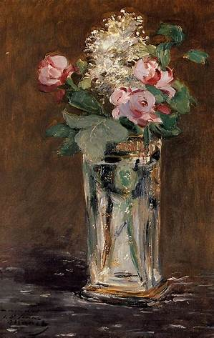  http://www.wikiart.org/en/edouard-manet/flowers-in-a-crystal-vase | 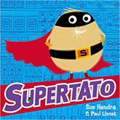  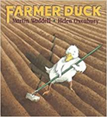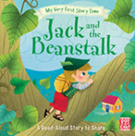 | Fruit containing seeds and magnifying glasses  Collage with seeds  Soil – investigation area  Growing seeds  Books about growing seeds  Images/photos/books  Bean discovery area  Land art using beans and seeds  Pots numbers to 5  Bean diaries  Role play – Jack and the beanstalk  Small world  Explorify
 |  | 3 wks - Grass  21/03/22 –  08/04/22 | 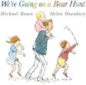  Phase 1 Aspect 7 Oral blending and segmenting  Tuning into sounds  To be able to demonstrate through games and role play an understanding of positional language.  Singing a range of number songs. |  | 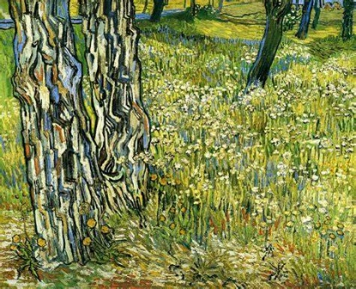  https://uploads7.wikiart.org/images/  vincent-van-gogh/tree-trunks-in-the-grass-1890.jpg | 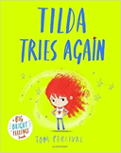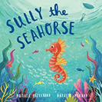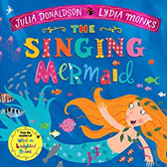 | Grow grass – grass heads  Role play – add garden magazines  Spot tray – cutting grass  Images of different grasses  Which animals eat grass?  Painting with grasses  Savannah grass land – small world  Books and images  Explorify
 | Summer 1 | 3 wks – Magic  25/04/22 – 13/05/22 | 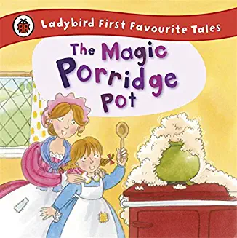  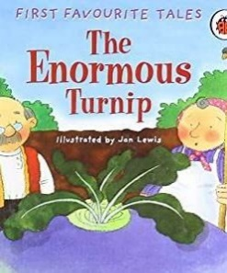  Phase 1 Aspect 7 Oral blending and segmenting Listening and remembering sounds  To subitise to 6.  To remember the order in which things happen.  To know that subtraction means taking an amount away from a group. | Tradition  Virtue |  | 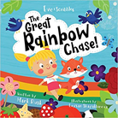  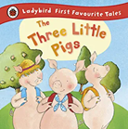 | Home corner  Home corner – role play  Small world  Dressing up area  Stories – book area  Sequencing pictures  Tasting porridge  Oats and containers
 |  | 2 wks – Garden  16/05/22 –  27/05/22 | 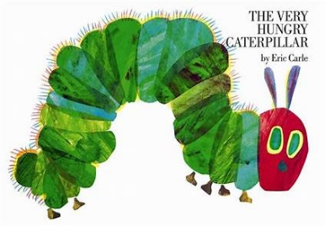  Phase 1 Aspect 7 Oral blending and segmenting  Talking about sounds  To know that some shapes more appropriate than others when building.  To remember different aspects of a journey, e.g. “I walked over a bridge to get to school”. | Common  Good | 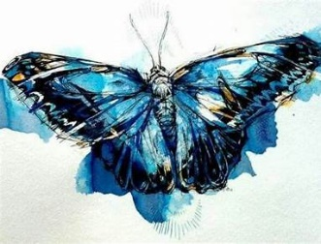  https://tse4.mm.bing.net/th?id=OIP.YNyh  AVdxfpGQSwe1QE4DoAHaFj&pid=  1.7&w=283&h=216&c=8&dpr=1.35 | 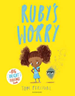  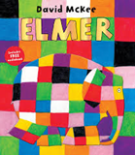 | Mini beast Hunt  Mini beast homes  Making caterpillars  Lifecycles – images  Observational drawing – flowers  Small world  Flower shop  Dough – petals, leaves etc  Flowers in jars – discovery area  Press flowers  Petal in ice cubes, herbs  Painting/drawing flowers  Collage area  Explorify
 | Summer 2 | 3 wks – Farm  06/06/22 –  24/6/22 | 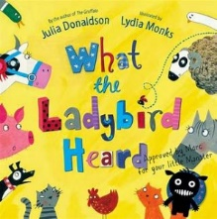  Phase 2  To subitise to 6.  To learn vocabulary linked to describing size and distance.  To be able to say number names forwards and backwards to 15. | Transformation | 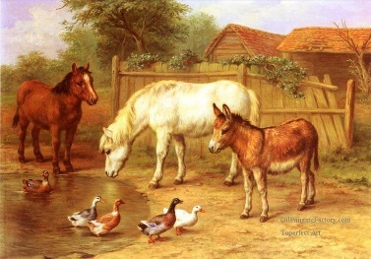  https://i.pinimg.com/736x/3d/2f/17/3d2f17d01f  43131fb358cf1802cb902f--farm-animals-oil-paintings.jpg | 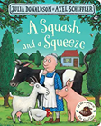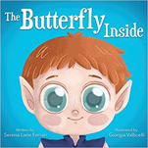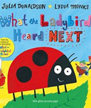 | Small world farm  Construction – blocks etc  Books and images  Observation drawing of crops  Sorting animals  Grow vegetables  Printing
 |  | 3 wks – Hot  27/06/22 – 15/07/22 | 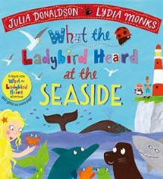  Phase 2  To remember the order in which things happen.  To remember different aspects of a journey, e.g. “I walked over a bridge to get to school”.  Positional language - | Well-being | 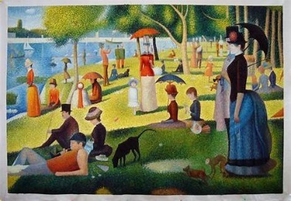  https://th.bing.com/th/id/R.3ba63503608cd550073b5303a1d  91cc0?rik=2Xlowd6L1yADRA&pid=ImgRaw&r=0 | 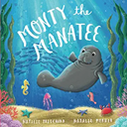  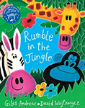  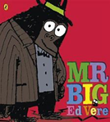 | Items related to going to the beach  Sand – buckets and spades  Sorting – what we wear when hot/cold  Picnic – making sandwiches  Small world – seaside/animals
Need to check finish date ** |  | 1 wk – ?  18/07/22 | Artists

