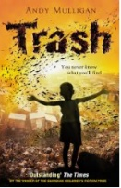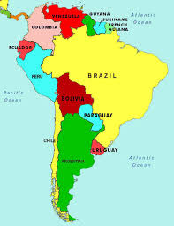 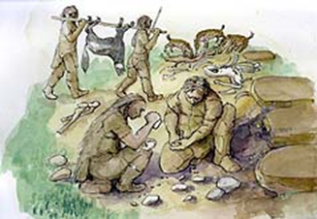[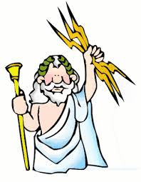](http://www.google.co.uk/url?sa=i&rct=j&q=&esrc=s&frm=1&source=images&cd=&cad=rja&uact=8&ved=0CAcQjRw&url=http://greece.mrdonn.org/greekgods/zeus.html&ei=yFIiVfudFOOt7ga5lIDgDg&bvm=bv.89947451,d.d2s&psig=AFQjCNHt7HQ5bJ9QiiGAY_YP8ZuSPgrk6Q&ust=1428399168094996)

**Important Information**

**Class Dojo**

Please ensure that you keep an eye on Class Story on ClassDojo to keep up to date with the happenings in school and follow our twitter too.

**SAT’s Update**

SAT’s week this year will be during the week of 11th May, 2020. Writing assessments will then take place throughout June 2020.

Booster sessions will be offered for children that would like to participate in these. Further details will be sent nearer the time re. these. The sessions take place from 2:55pm-3:30pm and will be free of charge.

**PE/Games**

We will be having two PE sessions a week. One will be indoor dance/gymnastics and the other will be an outdoors games session.

We advise that children bring their PE kit into school on a Monday and take it home on a Friday. This will ensure children can take part in all PE sessions should they need to be rescheduled to alternative dates for any reason.

**Our scheduled PE sessions are Monday (outdoor) and Tuesday (indoor).**

**Our Home Learning Schedule**

The following homework will be set for Year 6 weekly:

* 15 minutes reading per night (4 x per week to earn dojo points).
* Spellings (set and tested weekly).

We will also ask for a homework project each term. These ideas are suggested to the right.

**Our Curriculum**

|  |  |  |
| --- | --- | --- |
| **English:** | **Our novel of study will be**  **‘Trash’ by Andy Mulligan.**  We will be studying:   * Balanced Arguments * Newspaper Articles | |
| **Maths:** | We will be studying:   * + Fractions and Decimals   + Statistics | |
| **Project Study:**  Our key concepts, that will underpin our project study are:   * Common Good * Sustainability * Media   This will include a Geography focus based around:   * South America   The questions we look at answering and studying will be based around the children’s understanding and curiosity. | | |
| **R.E.:**  Who is inspiring? | **PSHCE:**  Growing Up - Responsibilities | **Art and DT:**  Food Technology  Painting and Collage |
| **Science:** Living things and their habitats | | |
| **Computing:**  Coding | **Music:**  New musical skills | **P.E.:**  Tag Rugby  Netball |

**Suggested Homework Projects**

***Due in by Friday 27th March***

* *Create a poster showing what you might find in an environment e.g. the rainforest*
* *Draw, label and explain the features of a chosen environment e.g. rainforest*
* *List the pros and cons of recycling as a poster.*
* *Create a limerick/poem to help remember to recycle*
* *Create a word search using words to do with the environment*
* *Create a fact file about an endangered species of animal including information about where it is found and why it is endangered (Science and Literacy)*
* *Find a book about a natural disaster and design your own information page about something you learn*
* *Design a job advert for someone to look after endangered animals*
* *Research a famous environmentalist and explain what they are famous for*
* *Make a poster about different habitats where you would find different species of animals*
* *Learn and perform a Zumba-style dance.*
* *Make a collage by gathering green materials from around your house and create the Reduce, Reuse. Recycle logo and take a photo*
* *Write a short quiz about different habitats and what you would find in them*
* *Draw or paint a portrait of David Attenborough (or a famous environmentalist)*
* *Create a comic strip based on a superhero who can save our planet – for inspiration look at Captain Planet*
* *Make some traditional South American Food*

**How is the Earth’s health**

**critical to our future?**