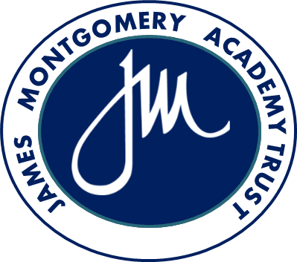
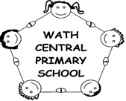

Our Mission
We value every child for who they are and prepare them for everything they could be.

Our Vision

For us, education is about:
- making memories and fulfilling dreams; It’s about the joy of discovery and the expression of individuality.

- children developing empathy whilst acquiring the knowledge and skills to prepare them for life as a learner.

- children feeling safe so they are ready to learn in the calm and supportive environment that allows them to flourish and exceed their own expectations.

- children understanding their role and responsibilities within a community; working together and accepting one another in an environment where diversity and inclusion go hand in hand.

We want our children to:
- be committed to learning, to be positive enough to see challenge as an opportunity and mistakes as valuable

- experience a curriculum that inspires and empowers them to be curious about the world; and to be brave enough to explore ideas and to question why.

- be filled with awe and wonder, to think creatively and use the power of their imagination.

For us it’s about togetherness. It’s about inspiring a community to achieve success.

