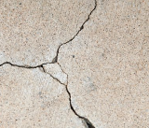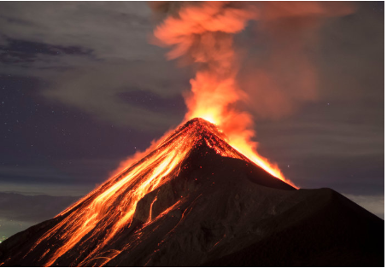 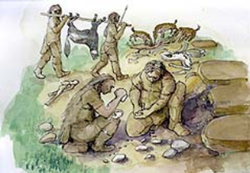[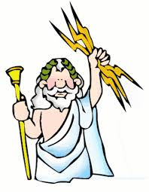](http://www.google.co.uk/url?sa=i&rct=j&q=&esrc=s&frm=1&source=images&cd=&cad=rja&uact=8&ved=0CAcQjRw&url=http://greece.mrdonn.org/greekgods/zeus.html&ei=yFIiVfudFOOt7ga5lIDgDg&bvm=bv.89947451,d.d2s&psig=AFQjCNHt7HQ5bJ9QiiGAY_YP8ZuSPgrk6Q&ust=1428399168094996)

**How Much Can Our Earth Handle?**

**Our Curriculum**

|  |  |  |
| --- | --- | --- |
| **English:** | **Our novel of studies will be based around two novels: The Iron Man and Tin Forest.**  We will be studying:   * Persuasive writing | |
| **Maths:** | We will be studying:   * Multiplication * Division * Fractions | |
| **Project Study:**  Our key concepts, that will underpin our project study are:   * Power * Change * Resilience   This will include a Geography focus based around:  Volcanoes and Earthquakes (natural disasters). | | |
| **Science:**  Scientific investigation  Rocks and Soils | | |
| **Computing:**  Kudo | **R.E.:**  Inspirational figures | **P.E:**  Games. |
| **Art:**  Sketching with focus of coloured pencil. Use of pastels. | **DT:**  Creating model volcanoes. | **PSHCE:**  Rights and Responsibilities |

**Important Information**

**Welcome back!**

Welcome back! We hope you have had a lovely, relaxing holiday.We hope that you are refreshed and are ready for another fun filled term of learning.

**Key Concepts**

This year, our curriculum will be based around key concepts with underpinning topics. As we enter our Geography term, we will be looking at a variety of areas linked to the concepts of ***power, change and resilience.*** The questions we look at answering and studying will be based around the children’s understanding and curiosity.

**PE/Games**

We will be having two PE sessions a week. One will be an indoor and the other will be an outdoor session. We advise that children bring their PE kit into school on a Monday and take it home on a Friday. This will ensure children can take part in all PE sessions. **Our scheduled PE sessions are Tuesday (outdoor) and Thursday (indoor).**

**Our Home Learning Schedule**

As a guide, the following homework will be set for Year 3 each week:

* 15 minutes reading per night (3 x per week or 4 x per week to earn dojo points)
* Spellings (set each Friday and to be learned/ returned by Friday)
* Times table practice. We care currently working on our 3 and 4 times tables. Times Table Rockstars is a good way to do this.

We will also ask for a homework project each term. These ideas are suggested to the right.

**Suggested Homework Projects**

***Due in week commencing Monday 16th March***

* Create a model volcano from different materials. This could be clay, Paper Mache etc. Decorate your volcano using media such as paint.
* **Create a fact file about volcanoes. Use the internet to gather as many facts about volcanoes as you can. Present this any way like.**
* Research natural disasters. How many different natural disasters can you find information about? Present this in a creative way.
* **Build and/ or design and Earthquake proof city. Explain what materials you have used and why these would withstand an earthquake.**
* Create an earthquake survival pack. Think about the food you would need and the clothes you would pack. Is there anything else you would need?
* **Create a collage of volcanoes. Show the different stages of a volcano eruption and what happens after/ what the area looks like after the eruption.**